**Lady Margaret Hall**

**Junior Common Room**

**General Meeting Minutes**

**Saturday, 30th November 2024, 7th Week MT24**

**Independent Chair: Asha Davison**

**Notices**

**Freddie James, JCR Treasurer** – Reminder to collect any unclaimed stash in the JCR!

The budget report for 23/24 and the budget 24/25 (full report included at the end of this agenda). Not fully confirmed, needs to go to governing body. Sports subscriptions now available in bar and JCR. MAD fund expanded to 1000 pounds now!

**Aniya Boranbay, JCR Secretary** – We will be running by-elections next week, so keep an eye out for that! Please have a look at the vacant roles over the vac and let me know if there are any you want to run for!

A big thank you to all the JCR officers who are finishing their terms. You have created so much positive change for our JCR!

**Motions**

**Motion 1: Get new darts for dartboard**

**Proposer:** Abigail Cherry

**Seconder:** Rory Shields

Notes:

Abigail – darts don’t work at the moment, nice that we have it. Flights won’t go in. As long as people take care of them they will last a while, don’t know where people have been throwing them.

Ike – there are holes in the wall.

Rory – agree. It’s a return on investment

Questions/comments:

? – I just threw a dart and it worked

Annabel – there seem to be less and less dartboards behind the bar

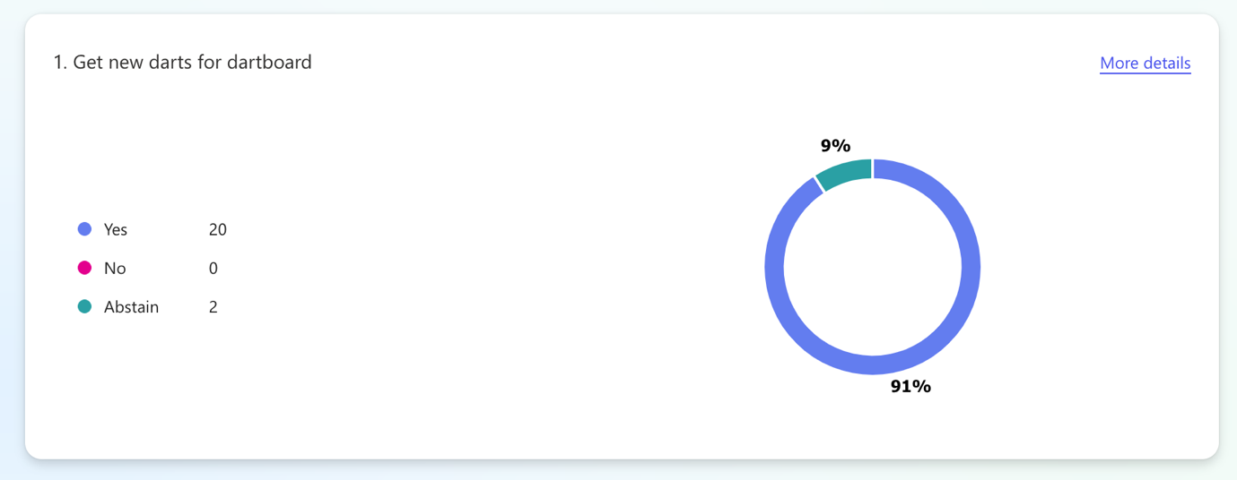

*Motion passed*

**Motion 2: To give £200 to establish a fund for purchasing games for the PS5**

**Proposer:** Travis Bennett

**Seconder:** Sam Davies

Notes:

Travis – we have the budget as per the budget report. We need games. Debates on what games are needed at JCR meetings.

Sam – Agree. No point to have expensive console without a way to enjoy

Questions:

Ike – is this a motion to move money from motions budget to another fund?

Freddie – This money will be set aside from the motions budget to lower the barrier of entry. Makes it easier

*Motion passed*

**Motion 3: Get an HDMI cable and Mario Kart for the Wii in the JCR**

**Proposer:** Simon Rettman

**Seconder:** Beatrix Lepsøe

Notes:

Simon – can’t plug the Wii console into the TV. Need an adapter to plug it into the TV and buy Mario kart. Probably around 30 pounds

Beatrix – very exciting for people, make it more accessible

Abby - What Mario kart

Simon – idk

*Motion passed*

**Motion 4: Make Pearl Crumb Independent Chair for HT25**

**Proposer:** Aniya Boranbay

**Seconder:** Travis Bennett

Notes:

Aniya – followed all necessary proceedings as per the constitution

Travis – yeah Pearl is great, she’s my college mum

*Motion passed*