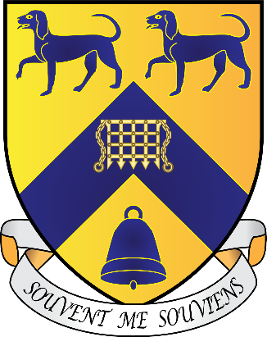**Lady Margaret Hall**

**Junior Common Room**

**General Meeting Agenda**

**Sunday, 17th November 2024, 6th Week MT24**

**Independent Chair: Asha Davison**

**Notices**

**Travis Benett, JCR President** – There is a PS5 in the JCR now! It doesn’t have wifi or any games yet, but working on getting it working. Should be done by next week!

University Challenge Team, check your email to see if you’ve made it!

**Ike Glassbrook, JCR Vice President** – Make sure to RSVP for the Christmas Gaudy if you have received an invitation. ASAP! The email should be in your inbox now!

**Freddie James, JCR Treasurer** – The bar TV has arrived and will be installed this

week, we have a Sky Sports and BT Sport for the bar and JCR TV. We will stream various sports games, wait for updates from Charli.

Chamber Choir will be singing Faures Requiem at 5:50pm on Tuesday in the Chapel. Free for anyone that wants to come along, great to see anyone that wants to come there!

**Motions**

**Motion 1:** To give £175 to the Alison Brading Circle

**Proposer:** Nydile Narayan

**Seconder:** Aria Appoo

**This JCR notes that:** The ABC is LMH’s society for those studying Medicine and Biomedical Sciences. The 175 pounds would be for the whole year.

**This JCR believes that:** The money would be spent on snacks and drinks (at events open to all members of college) and reimbursing external speakers’ travel expenses.

**This JCR resolves to:** Give £175 to the Alison Brading Circle.

**Notes:**

For:

Nydile – Co-president of ABC. Asking for 175 pounds for whole year, no more money now, asking for more this year (15 pounds). Have biomed students this year for the first time.

Aria – exactly what Nydile said, please give us money to make sur everyone can learn about medical sciences

Lewis – highly recommends as member of the ABC, great events

*Motion passed*