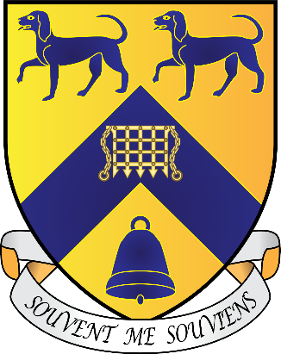**Lady Margaret Hall**

**Junior Common Room**

**General Meeting Agenda**

**Sunday, 17th November 2024, 6th Week MT24**

**Independent Chair: Asha Davison**

**Notices**

**Travis Benett, JCR President** – There is a PS5 in the JCR now!

University Challenge Team

**Ike Glassbrook, JCR Vice President** – Make sure to RSVP for the Christmas Gaudy if you have received an invitation

**Freddie James, JCR Treasurer** – The bar TV has arrived and will be installed this

week, we have a Sky Sports and BT Sport for the bar and JCR TV

Chamber Choir will be singing Faures Requiem at 5:50pm on Tuesday in the Chapel

**Motions**

**Motion 1:** To give £175 to the Alison Brading Circle

**Proposer:** Nydile Narayan

**Seconder:** Aria Appoo

**This JCR notes that:** The ABC is LMH’s society for those studying Medicine and Biomedical Sciences. The 175 pounds would be for the whole year.

**This JCR believes that:** The money would be spent on snacks and drinks (at events open to all members of college) and reimbursing external speakers’ travel expenses.

**This JCR resolves to:** Give £175 to the Alison Brading Circle.