**Lady Margaret Hall**

**Junior Common Room**

**General Meeting Minutes**

**Sunday, 13th of October, 1st Week MT24**

**Independent Chair: Asha Davison**

**Notices**

**Ike Glassbrook, JCR Vice President** – Findings from voter registration investigation

Issues with voter registration in May 2024 council elections. Registration with respect to Oxford University registration – didn’t happen. If there was an issue with registering – contact oxford city council (look up, first result). Next election for council is in 2026, extra communication

Overview of the work pursuant to the ethical practices demands of Trinity 7th week JCR meeting

Motion passed with regards to ensure college policies are in line with ethical standards (with respect to genocide in Gaza and fossil fuels). Report will be presented to governing body in 4th week. Concerns with regards to student welfare (with regards to how the university dealt with protests and antisemitism and islamophobia). Safeguards have been put in place with speaking with the university and JCRs and MCRs across Uni.

Reminder for freshers to join the Facebook

You will miss out if you are mot on the Facebook! Everything is secondary to the Facebook.

**Travis Bennett, JCR President** –

Thank you so much to the Fresher’s Reps!!!

Thank you to the bar staff and entz reps for the amazing BOP.

Letting everyone know of the vacant JCR officer positions

All on the website. Good time to get involved for freshers!

University Challenge

Auditions and trials will be held soon (details will be sent later in an email)

**Elly Bailey, JCR Women*s Officer** –Announcement about the period products in the bathrooms around college

College is now funding the stocking of the period products. Email Elly (jcr.gender@lmh.ox.ac.uk) if the bathrooms are low on stock.

**Motions**

**Motion 1:** LMH Law Society Funding

**Proposer:** Ella Stranger

**Seconder:** Tanvi Kothari

**This JCR resolves to:** provide LMH Law Society with £170 of funding, which will be used to organise events throughout the year along with sponsorships arranged personally by the Society.

**Notes:**

Ella – LawSoc for both Law and non Law students. Issue with funding last year. 170 is a steep amount – aware of that. College does not fund catering, speakers, etc anymore. Lots of great events open to everyone this year. Some speakers are free but expect a certain level of catering. Events are well attended. Funding for the whole year.

Tanvi – to repeat: non law students are very welcome, lots of events that appeal to a broad range of students. No need to be a law student

Speak for:

Cora – attended events last year, good because the university ones are difficult to get spaces at

Speak against:

None

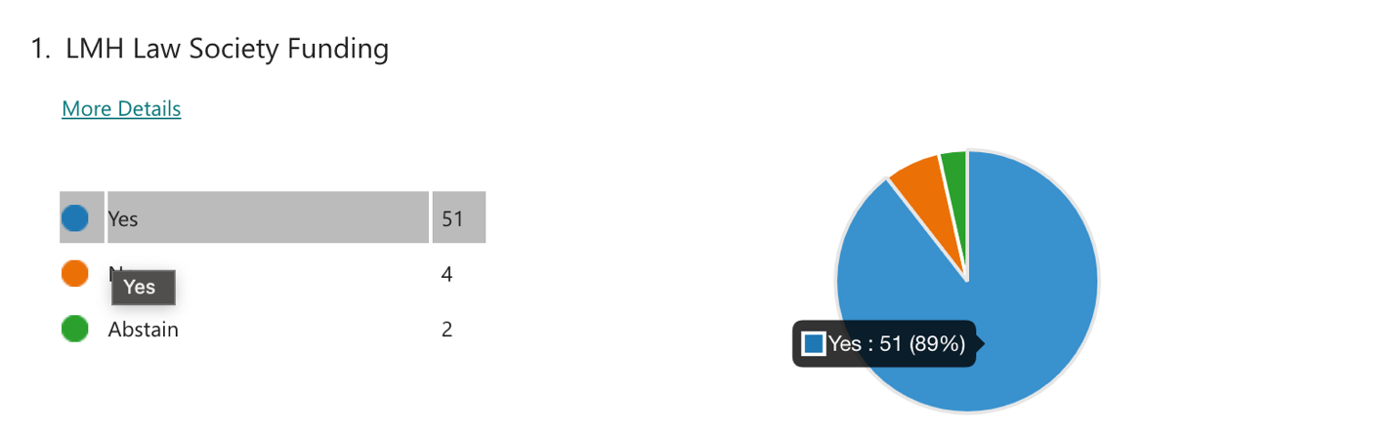

***Motion passed.***

**Motion 2:** History Society Funds

**Proposer:** Ava Lewallen

**Seconder:** Elly Bailey

**This JCR resolves to:** Give history society £75 (Motion was amended from £60 to £75)

**Notes:**

Ava – ask for 75 pounds, lot of great speakers coming every other week. Free catering for students and transport for speakers. Bar crawls, crewdates, pizza nights etc. Minimize out of pocket spending

Elly – Anyone is invited to history society. The society is bigger than it has ever been before, lots of freshers joining. More events this term and year than have ever been run before. Expand membership as much as possible

Speak for :

Ike – in the JCR history society has been well run and used the funds well. JCR has the budget

Questions

Freddie – how long is this funding for

Elly – as long as possible (hopefully into next term). Will come again for extra funding later in the year

***Motion passed.***